DATE: 11.01.2019
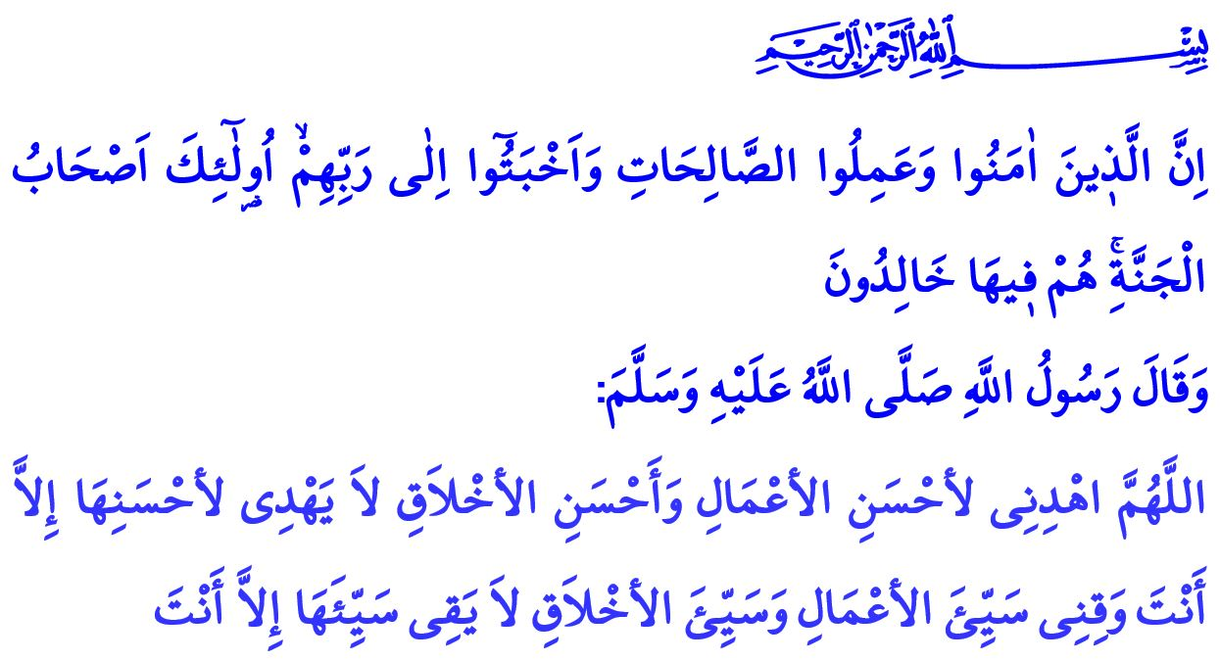
MAN'S JOURNEY TO PERFECTION: ISLAM, FAITH AND BENEFICENCE
Honorable Muslims!
One day while the Prophet (s.a.w.) was sitting with the companions, a man came up, whose clothes were extremely white, whose hair was extremely black, upon whom traces of traveling could not be seen, and whom none of the companions knew, who sat down close to the Prophet (s.a.w.) and asked, ‘What is Islam?’ Allah's Messenger (s.a.w.) replied: “To worship Allah Alone and none else, to offer prayers perfectly to pay the compulsory charity (Zakat) and to observe fasts during the month of Ramadan, and you perform the hajj of the House if you are able to take a way to it.”
He said, 'You have told the truth,' Companions were amazed at him asking and [then] telling that He told the truth. Then he further asked, 'Tell me about Iman/faith.' Allah's Messenger (s.a.w.) replied: “Faith is to believe in Allah, His angels, His Books, His Apostles, and to believe in Resurrection, and that you believe the Decree, the good of it and the bad of it.” He said again, 'You have told the truth,' Then he further asked, 'Tell me about Ihsan/ beneficence.' Allah's Messenger (s.a.w.) replied: “To worship Allah as if you see Him, and if you cannot achieve this state of devotion then you must consider that He is looking at you.” He also asked some questions about the apocalypse and left. Our Dear Prophet (s.a.w.), told Omar (r.a.) who witnessed the event: ‘That was Gabriel who came to teach you, your religion.’
Valuable Believers!
Faith is the affirmation of Allah's existence and unity and what Our Prophet brought from Almighty Allah, with the heart and the language. Faith is the bond of love and trust between the servant and Allah. Faith is the loyalty and sincerity promise of man who knows the purpose of creation. What is befitting to human beings, is to stand by this promise and fulfill its requirements.
Valuable Muslims!
Islam is to live as we believe and to reflect faith on our lives. To worship Allah with complete submission, to devote all our material and spiritual existence to His way, to obey his orders, to avoid prohibitions. It is this Muslim's loyalty to Allah in His words, deeds and behaviors, and his willingness not to associate anything with Him.
Valuable Muslims!
The beneficence in the Gabriel hadith is the awareness of servitude and the peak of beautiful morality. Beneficence is to feel the presence of Our Lord in every moment of life, who declares that “…We are closer to him than [his] jugular vein.” This is to live in the presence of Our Lord in divine supervision and blessings, in accordance with the “…He is with you wherever you are. And Allah, of what you do, is Seeing” verse, in the spirit of needing His favors and His support.
Esteemed Believers!
To believe, to carry out the worship of Islam, and to act with the consciousness of beneficence, is like steps that complement each other. A person who believes in Allah and the verities that He has revealed will of course strive to be a sincere Muslim by not disrupting or hindering his worship. The indispensable necessity of faith and worship is to have good morals. The person who believes but does not perfect it with worship and good morality, is in a misadventure. A person who is not crowning his morality with faith and worship will be deprived of the contentment of Allah. Anyone who is worshipping, but who has a weakness in terms of faith and morals, cannot see the benefits of the worship which remains as only a form, not the full content of worship. Therefore, every person who is pleased being a servant of Allah, Islam as a religion, Muhammad (s.a.w.) as the Prophet, should beautify their faith, worship, and morality altogether. That is when the believer will receive this herald of the Holy Qur'an: “Indeed, they who have believed and done righteous deeds and humbled themselves to their Lord - those are the companions of Paradise; they will abide eternally therein.”
Honorable Muslims!
Let us not deprive our soul of a blessing such as faith, a food such as worship, a consciousness like beneficence. Because all kinds of good, auspiciousness and the base of verity, the meaning of being human, and the value of servitude are hidden in these three ores.
Let's be sincere and diligent on the road to servitude. Let us keep in mind that every word that is poured out of our tongue, every work that is out of our hands, every view we see with our eyes, every step we take has a return on the level of Supreme Allah.
I conclude my khutbah with the prayer of Our Dear Prophet (s.a.w.): “O Allah, guide me to the best of deeds and the best of manners, for none can guide to the best of them but You. And protect me from bad deeds and bad manners, for none can protect against them but You.”

Bukhari, Belief, 37.
Qâf, 50/16.
Hadîd, 57/4.
Hûd, 11/23.
Nasâi, Commencement of the Prayer, 16. General Directorate of Religious Services

